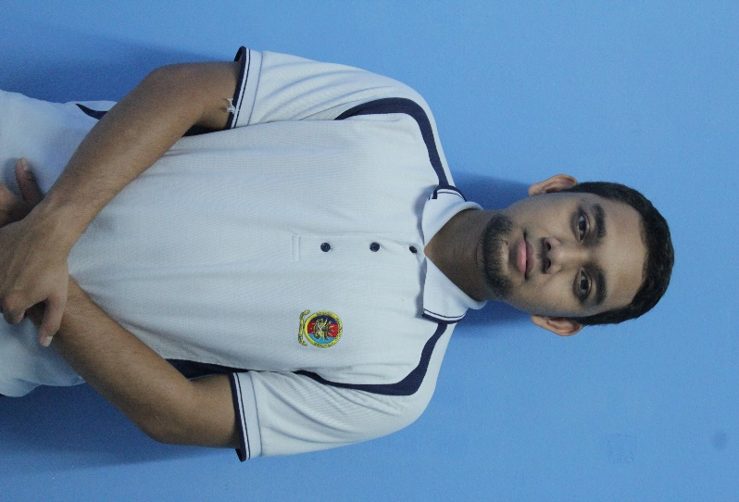RESUME

MUHAMMAD FARIS BIN DARUS

Blok 35-01-10 Pangsapuri Sri Langkawi 2,

Jalan Gombak,

53100, Kuala Lumpur,

Wilayah Persekutuan.

Telephone no : 013-3337359

E-mail Address : farisdarusalbaghdadi@gmail.com

|  |  |
| --- | --- |
| **PERSONAL PARTICULARS** |  |
| **Date Of Birth : 19 MEI 1993** | **Place Of Birth : KUALA LUMPUR** |
| **Marital Status : Single** | **Sports : Football / Futsal** |
| **Hobbbies : Fishing** | **Willingness to travel : YES** |
| **Nationality : Malaysian** |  |

|  |  |  |
| --- | --- | --- |
| **EDUCATION** |  |  |
| **Sept 2014 - Dec 2017** | Universiti Kuala Lumpur, British Malaysian Institute. | Bachelor of Engineering Technology (Hons) in Electrical |
| **Jun 2011 - May 2014** | Politenik Sultan Azlan Shah Behrang Stesen,35950 Behrang. | Diploma in Electrical Engineering |
| **Jan – Jun 2011** | GiatMara Kuala Lumpur | Electronic Industry |
| **2009 - 2010** | Setapak Technical School,  Jalan Setapak Indah,5300  Kuala lumpur,Wilayah  Persekutuan. | SPM with distinctions in Applied Science and History. |

|  |  |
| --- | --- |
| **WORKING EXPERIENCE** |  |
| **Dis 2012-May 2013** | Practical Training at **StatchipPAC Malaysia Sendirian Berhad**  Exposure gained   * **Operating wafer processing machine.** * **Operating Taping, Backgrind, Wafer Mount, and Backgrind maching.** * **Installing electronic chips.** * **Conducting the wafer loading process into the factory.**     **SALARY : RM 350.00** |

|  |  |  |
| --- | --- | --- |
| **EXTRA-CURRICULAR ACTIVITIES** | |  |
| **2016 - 2017**  **Jun & Sept 2015** | ***Commitee Surau Kompleks Asuhan Mahasiswa Islam University Kuala Lumpur British Malaysian Institute (KAMI)***  ***Facilitator Welcoming Orientation Week University Kuala Lumpur British Malaysian Institute*** | |
| **Sept 2014**  **Jun 2013** | **Active members** of the **Ikatan Studi Islam** of **Universiti Kuala Lumpur, British Malaysian Institute**  ***Spiritual Exco in DET Club*** of ***Polytechnic Sultan Azlan Shah*** | |
| **Jan 2012- Nov 2012**  **Jan 2012 - Now**  **Jun 2011** | ***Polythecnic Students Representative Board (JPP)*** of ***Polytechnic Sultan Azlan Shah***  **Askar Wataniah (PRIBATE)**  **Active members** of the **Rakan Pusat Islam** of **Polytechnic Sultan Azlan Shah** | |

|  |
| --- |
| **SKILLS / STRENGTHS** |
| * **Proficient in Microsoft Word, Power Point and Excel, and Autocad 2015** |
| * **Full clean driving license (B,D,) – familiar with Kuala Lumpur and Selangor areas.** |
| * **Can work easily when under pressure and meet tight deadlines** |
| * **Speak fluent Bahasa Malaysia and English** |
| * **Fluent in written Bahasa Malaysia and English** |

|  |
| --- |
| **HONOURS & AWARDS** |
| * **The best student award for trial on SPM examination** |
|  |
|  |
|  |

|  |
| --- |
| **OTHER INFORMATION** |
| **I can do the wiring installation. In addition, I enjoy travelling and meeting people very much. Therefore, I would be a good candidate to do outstation works for the company.** |

|  |  |
| --- | --- |
| **REFERENCE** |  |
| The following persons have agreed to provide any additional information regarding my qualifications and character : | |
| Sir Abdul Halim Bin Abd Rahman  Academic Advisor  University Kuala Lumpur British  Malaysian Institute.  Tel: 0 16-382 7100  [abdhalim@unikl.edu.my](mailto:abdhalim@bmi.unikl.edu.my) |  |